This is a Low poly Boat yard
With one texture and one material for all.
In this package
-1 House.
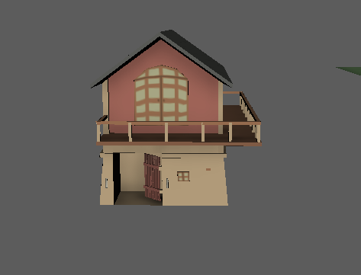
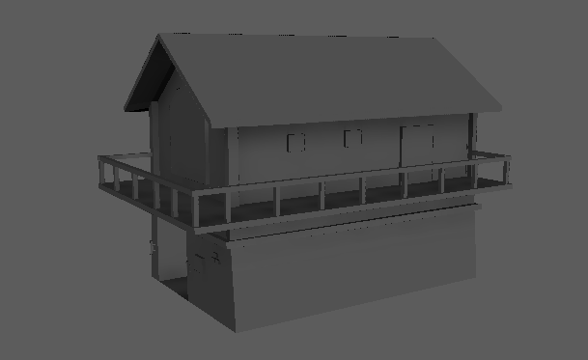
-2 Boats.
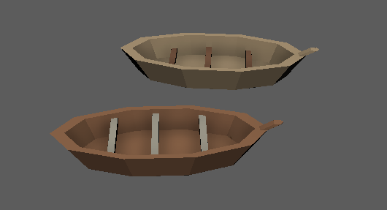
-3 Boat paddles.
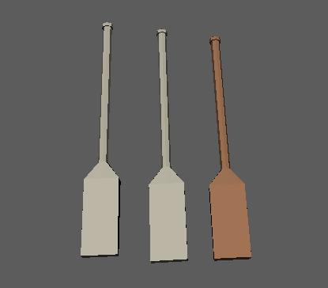
-2 Buckets.
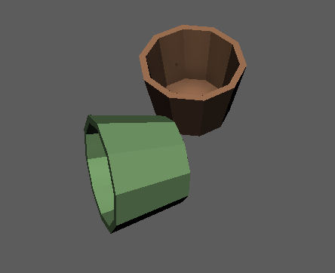
-1 wall.
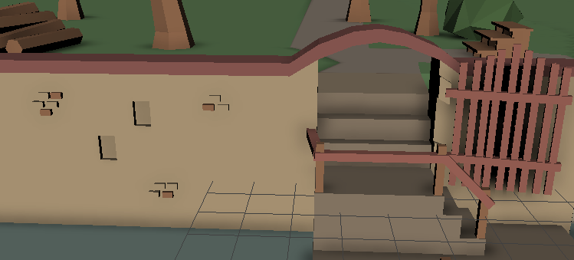
-14 trees.
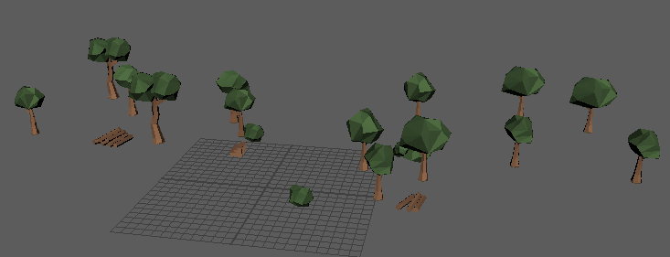
-1 texture (2048 x 2048 px).
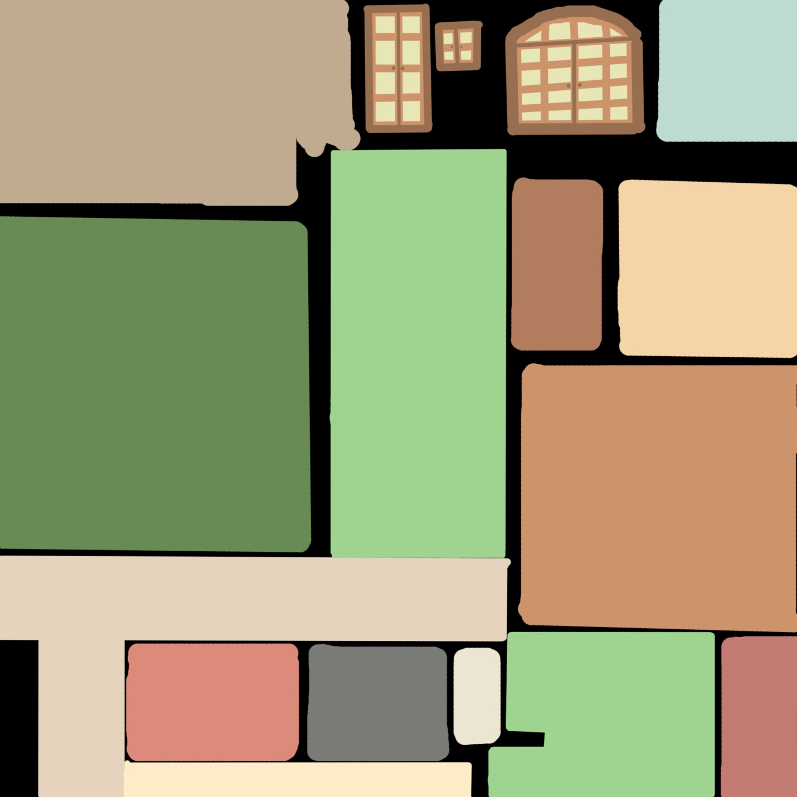
Please rate and comment our work. Let me know if something is wrong or needs to be
Improved
Abhishekshindekar@gmai.com

